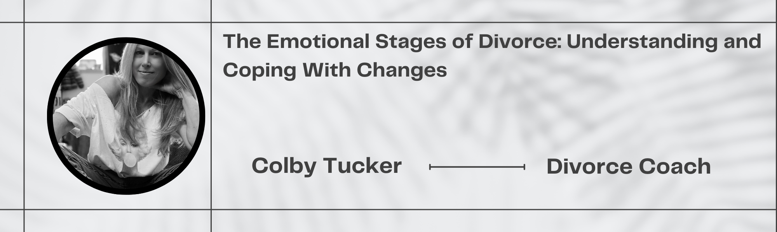
What are the emotional stages of divorce?
- Stage One: Denial
- Stage Two: Shock/ Sadness
- Stage Three: Bargaining
- Stage Four: Letting Go
- Stage Five: Acceptance

Need help getting through the process and emotions?
Schedule your introductory call and get the first 20 mins free!
Colby Tucker-Divorce Coach -352-342-4416

www.exitsigndivorce.com | Follow me at Facebook, Instagram, Youtube


